

Brno – Czech Republic

Production number | Date of prod. | Manufacturer

index

index 3
Introduction 4
Basic safety 5
Putting the gun into operation, dry firing 5
Filling the gun with CO₂ 6
Using the 12g CO2 cartridge (fig.1) 6
Using the filling valve (fig.2) 6
Loading the gun, shooting (fig.3,4) 7
Adjustments 8
Grip adjustments 8
Sight adjustments 8
Trigger adjustments 8
Cleaning of the gun 10
Technical specifications 11
Technical specifications 11
Standard accessories 11
Optional accessories 11
APPENDIX A - AERON B96 assembly 12
APPENDIX b - AERON B96 part list 13

Instructions for using, maintenance and handling of the self-loading pistol AERON B96

Introduction
The match self-loading five-shot CO2 pistol model AERON B96 is intended both for sports shooting and for competition shooting complying with ISSF regulations for “Air Pistol event” and “Air Pistol Rapid Event”. It can be used either as a single shot or five shot rapid-fire weapon.
The high technical standard with the precision LOTHAR WALTHER company barrel coupled with new compensator design and a lot of variable elements make it possible to meet all individual requirements of the shooter.
The most important characteristics of this up-to-date weapon is the variable tilt of the anatomical walnut grips ranging from 110 to 125, even when the pistol is under pressure. This ensures together with the additional weight optimum hold and excellent stability when shooting.
Unique 5 shot cartridge shifting mechanism design allows extremely short rapid-fire times while keeping well designed shooting precision at the same time. All five pellets can be fired in less than 3 seconds.

Basic safety
- Do not use the pistol until you have completely read this manual.
- A loaded firearm has the potential to cause injury. Intelligently handled it is safe.
- An accident is always the result of basic safety rules neglect.
- Accident prevention is user responsibility
- Always treat firearm as if it were loaded.
- Never point a firearm at anything you don’t want to shoot.
- Never shoot at a flat surface.
- Before loading a firearm, be sure you know how it functions.
- Always use only quality pellets intended for gas guns, taken out from original packing and immediately loaded into the magazine.
- Do not use deformed or corroded pellets.
- Keep clean both the pistol and magazines.
- The gun is designed exclusively for using CO₂.
- Never use excessive force when disassembling or assembling the gun.
- Before each filling of the gun with gas cock the striking mechanism and put the safety on.
- Use the safety after shooting or before each manipulation with the gun.
- Keep the gas cartridge container located in the grip slightly preserved by appropriate lubricant.
- Do not transport the pressurized gun.
- Do not expose gas charged gun to temperatures above 40 °C (104 °F).
- Do not expose gas charged gun to direct sunlight.

Putting the gun into operation, dry firing
Before using clean dry both the gun surface and barrel bore. Cock the pistol striking mechanism by the crossbar (26) in the direction to the barrel muzzle and put on the safety (34) on the right side of the gun.
The safety limits the movement of the crossbar in both directions. It enables free let-off without releasing the propelling gas – dry training. After each trigger squeeze you have to cock the striking mechanism by the crossbar (26). Keep the safety on.

Filling the gun with CO₂
Before each filling of the gun with gas cock the striking mechanism and make sure the gun is not under pressure.

Using the 12g CO2 cartridge (fig.1)
Unscrew the piercer (81) from the container (14) in the pistol grip with the safety on, put the cartridge wit 12 CO2 (type Crosman or similar with o.d. 19x83mm) in the container with its head out from the grip. Screw on the piercer. After piercing – it proves by increasing of the opposition, screw the piercer furthermore about ½ turn. Use the standard accessory key (87).

Using the filling valve (fig.2)
On the gun without pressure replace the piercer in the grip by the filling valve (202), you have to screw it on till the stop. Take off the cap from the filling valve thread. Cock the striking mechanism and put the safety on (34). Place the pistol on a soft rest with the sights down (grip up) and keep the gun in this position during the filling process. Screw the CO2 pressure cartridge (150g CO2) till the stop on the filling valve thread.
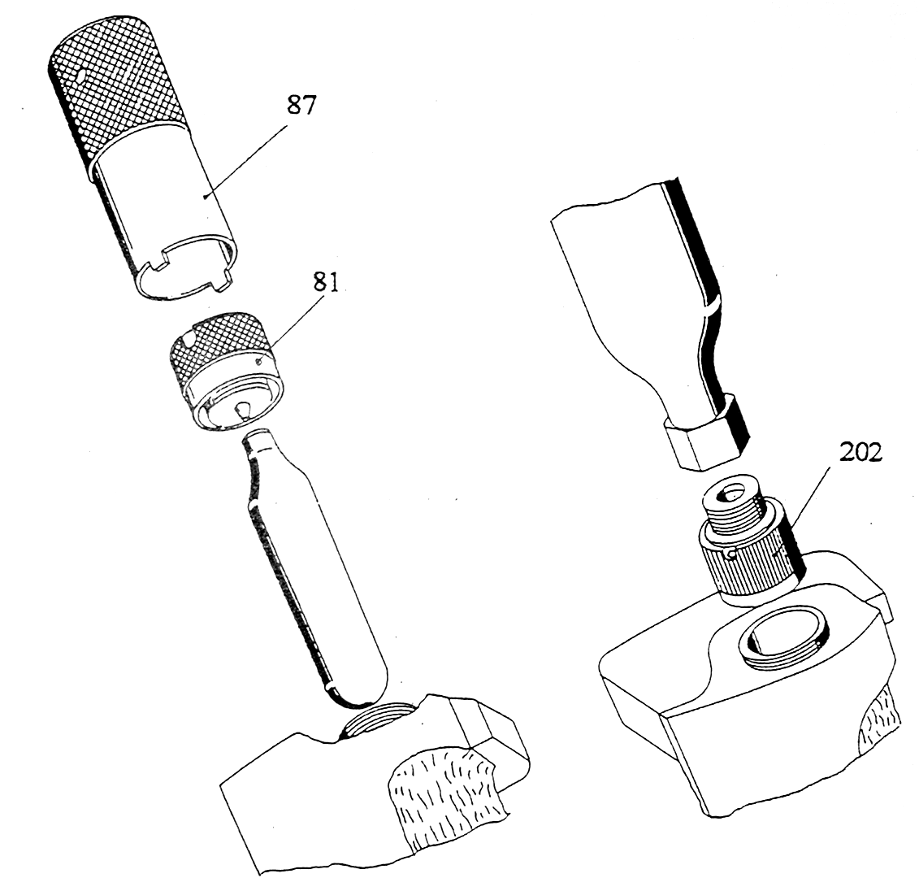
In unchanged position put the safety off and shoot 4 shots without pellets. Put the safety on and let the pistol rest for 1 minute. Unscrew the pressure cartridge and put on the cap. Turn the pistol to normal position for shooting.
When the feeder (37) with the magazine (1) or without the magazine is not moved till its stop on the left side (e.g. not all 5 shots are fired), push lever (A) upwards in the dart direction. While the lever is pushed the feeder (37) with magazine (1) can be moved till its stop on the left side (see dart direction). After depressing the feeder (see the next section) the magazine (1) can be moved out of the pistol or inserted back.

Loading the gun, shooting (fig.3,4)
Move the feeder till the left stop – see remark above.
Depress the protruding end of the feeder (37) in order that the draw bar (38) snaps under the lower end of the link (41) and when it is depressed take the magazine (1) out of the gun (fig.4). Load all 5 magazine chambers with pellets and push them in as so they do not protrude out of the magazine edge.
Pellet orientation: When looking at oval shaped slot in the magazine next to the chambers – the pellet forefronts are heading away from the shooter.
Insert the magazine into the pistol and push the feeder (37) without force till the stop. Improperly oriented magazine cannot be inserted into the pistol. When the pellets are not properly inserted, the magazine rubs and the gun function is not guaranteed.
The pistol is prepared for shooting after putting the safety off or after putting the safety on the dry let-off is possible without releasing the propelling gas.
! Before putting the safety off it is always necessary to cock the striking mechanism, otherwise an unintentional shot could be fired after putting the safety off !
After the last shot the feeder (37) is in the outward position, the trigger mechanism cannot be released. At the end of shooting put the safety on and push the feeder (37) with inserted empty magazine into the gun till stop. If you are not going to shoot for a longer time, let the gas off the pistol in the following way:
Check if in the magazine (1 or 9) or in the barrel bore is not a pellet or a foreign object. Insert the magazine into the pistol and push the feeder (37) till the stop. Put on the safety (34). Pull the trigger. Keep the crossbar and put the safety off. By forcing the crossbar backward the gas from the container will be released through the barrel bore.
The barrel muzzle must be pointed to a safe place!
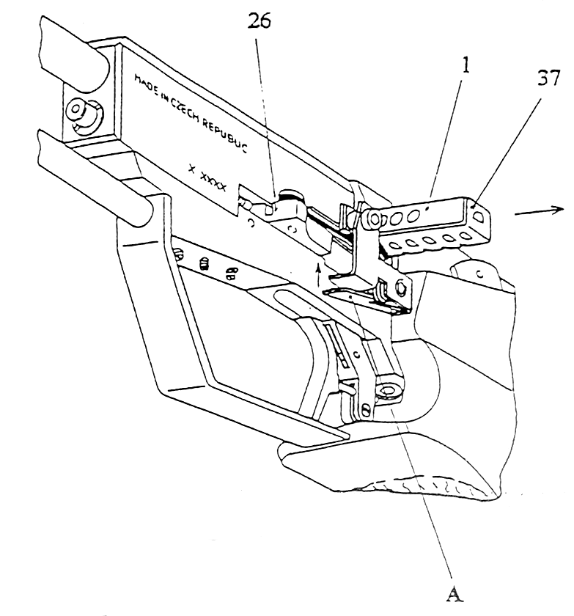
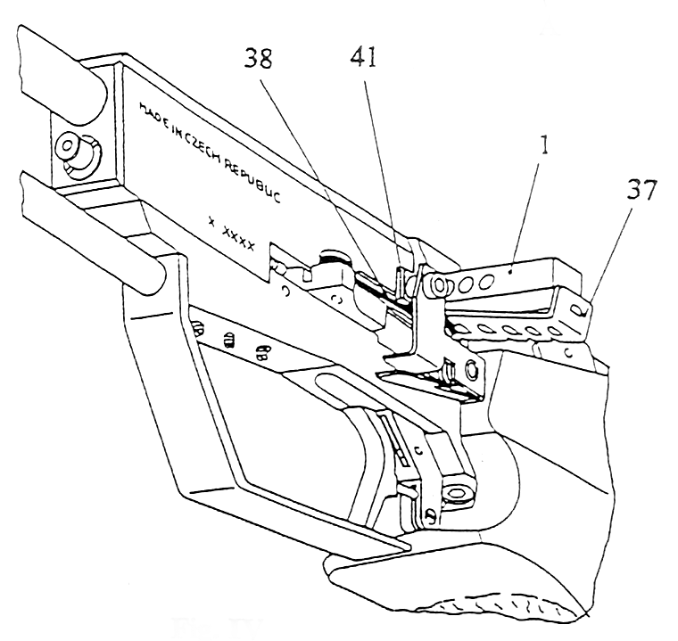
The gas can be released by shooting without pellets as well.
Never try to let the gas off by unscrewing the piercer or filling valve!

Adjustments

Grip adjustments
The grip tilt can be adjusted after releasing the screw (7) on the container (14) with a peg wrench. The screw is on the right side of the pistol. The palm rest is a\adjustable after releasing screws (67). After adjusting tighten the screws without excessive force.

Sight adjustments
The front sight (5) can be replaced after unscrewing the screw (6). The windage adjustment of the rear sight is done knob (77a). Turning it clockwise moves the rear sight blade to the left. The rear sight elevation adjustment is done by knob (77b). Turning it clockwise moves the rear sight blade up.
Rear sight notch adjustment (fig.5)
By loosing the rear sight blade screws (74) release both of rear sight blades (95,96). By turning the stopping spring (80) during simultaneous pressure on both of rear sight blades in the dart direction adjust the required width of the rear sight notch. Tighten both rear sight blade screws.
Vertical position of setting bolt’s slots means minimum width of rear sight notch. Horizontal position means maximum width.
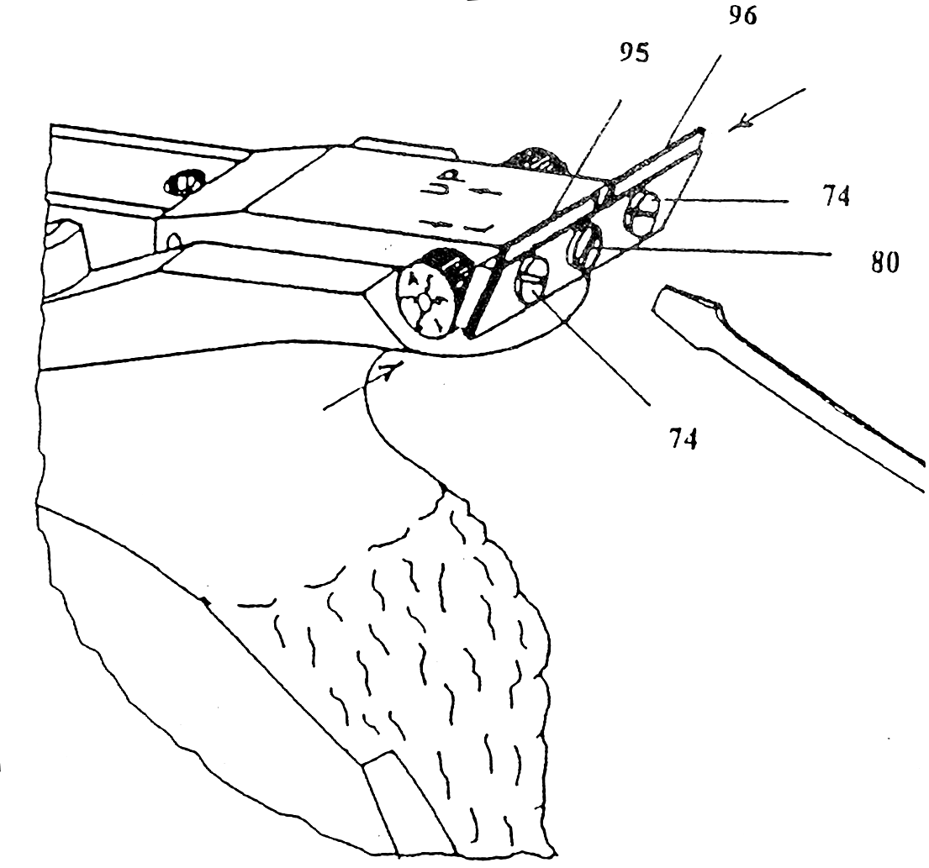

Trigger adjustments
Used tools: screwdriver 3,5 x 0,5 (from accessories )
- FUNCTION OF INDIVIDUAL SETTING SCREWS:
58a – setting rear trigger stop
58b – setting front trigger stop
59 – setting trigger weight with booster spring (60)
WARNING: all setting screws are equipped with special paste for anti disengagement. In case of frequent adjustments the screw need to be cemented again!

- STARTING POSITIN BEFOR ADJUSTMENT:
- The pistol has to be without gas pressure!
- Unscrew the trigger guard by holding the weight (3) and bar (2) and take the trigger guard off.
- Relese the setting screws (59,58,58b) so that the trigger has large latency. Don´t unscrew the setting screw completely.
- Cock the gun and put the safety on.
NOTE: putting the safety on is necessary so that the hammer does not move into its dead posiition whole setting the trigger.
The safety must be on while the whole setting process described in paragraphs C,D,E,

C.SETTING THE REAR TRIGGER STOP
Screw the screw (58) so that trigger aftertravell is minimal ( about 0,5mm )

D.SETTING THE FRONT TRIGGER STOP
- Cock the gun
- Screw in the screw (58b) to set the first trigger travell length to your needs. The first trigger travell length can be set to a minimum of about 0,5 mm so that the trigger lever (52) still safely clicks under the reduction tooth (62)

E. SETTING THE TRIGGER WEIGHT
1. Cock the gun
2. Screw in the screw (59). Set the trigger weight according to ISSF regulations
WARNING:
When setting the trigger weight keep checking if the hammer still can be released by pushing the trigger. If you screw in the screw (59) too much the trigger will not be able to move any more!
If the weight is not set to sufficient to your needs, the spring (60) needs to be replaced for a stronger one. Standart spring (60) will let you set the weight from about 400 – 800 grams.

F. TRIGGER ADJUSTMENT CHECK
1. Cock the gun
2. Fill the gun with gas according to the manual and fire the gun with empty cartrige.
Described setting will guartatie safe operation of the gun.

Cleaning of the gun
The gun should be cleaned without gas pressure!
For maintaining of the proper function of the self-loading pistol AERON B96 you have to keep it clean. Do not store the pistol without casing and in dusty or humid environment. All moving parts can be only very lightly lubricated with gun oil. Do not lubricate the pistol too much. The oiled parts should be wiped. The remaining oil film is sufficient. The barrel should be cleaned with cleaning rod with soft surface with the help of cotton-wool and drop of oil. From time to time lightly lubricate the container cavity (14) and exposed parts of the piercer (81) and the filling valve.

Technical specifications
Caliber 4.5 mm / .177”
Length 355 mm / 14.0”
Height 160 mm / 6.3”
Width 49.5 mm / 1.9”
Weight ~1050 g / ~2.2 lbs
Barrel length 210 mm / 8.3” (230 mm, 254 mm / 9”, 10” optional) (w/o compensator)
Sight radius 325 mm / 12.8” (with 210 mm / 8.3” barrel)
Sights front: interchangeable, 3.5 – 5 mm
rear: micrometer adjustable in height and lateral directions. Adjustable blade 2.8 – 3.8 mm
Trigger adjustable trigger stop, weight, length and tilt
Trigger weight adjustable
Grips anatomical right or left walnut grips with adjustable tilt 110° – 125°
Additional weight* displaceable 90 g / 0.2 lbs, 75 mm / 2.95” travel
Cartridge capacity 5 pellets (or 1 pellet according to ISSF regulations)
Energy source CO₂ filling from external pressure source with charging adaptor* (or included 150g refillable pressure gas cylinder) or standard 12g CO₂ cartridges
Velocity ~135 ms⁻¹ / ~443 fps
Accuracy c-t-c (10 m) < 2.00 mm / < 0.079”
Shot energy 4.56 J
Number of shots > 60 from 12g cartridge
> 100 from internal pressure tank
5-shot rapid fire time < 3 s

* other sizes / weight may be ordered

Standard accessories
  - A rigid profiled carry case for one pistol and accessories
  - Brass charging adaptor for included 150g pressure gas cylinder
  - Piercer unit
  - Set of standard tools

Optional accessories
  - Front sight 3.4 mm, 4 mm, 4.5 mm, 5 mm
  - Complete left grip

APPENDIX A - AERON B96 assembly

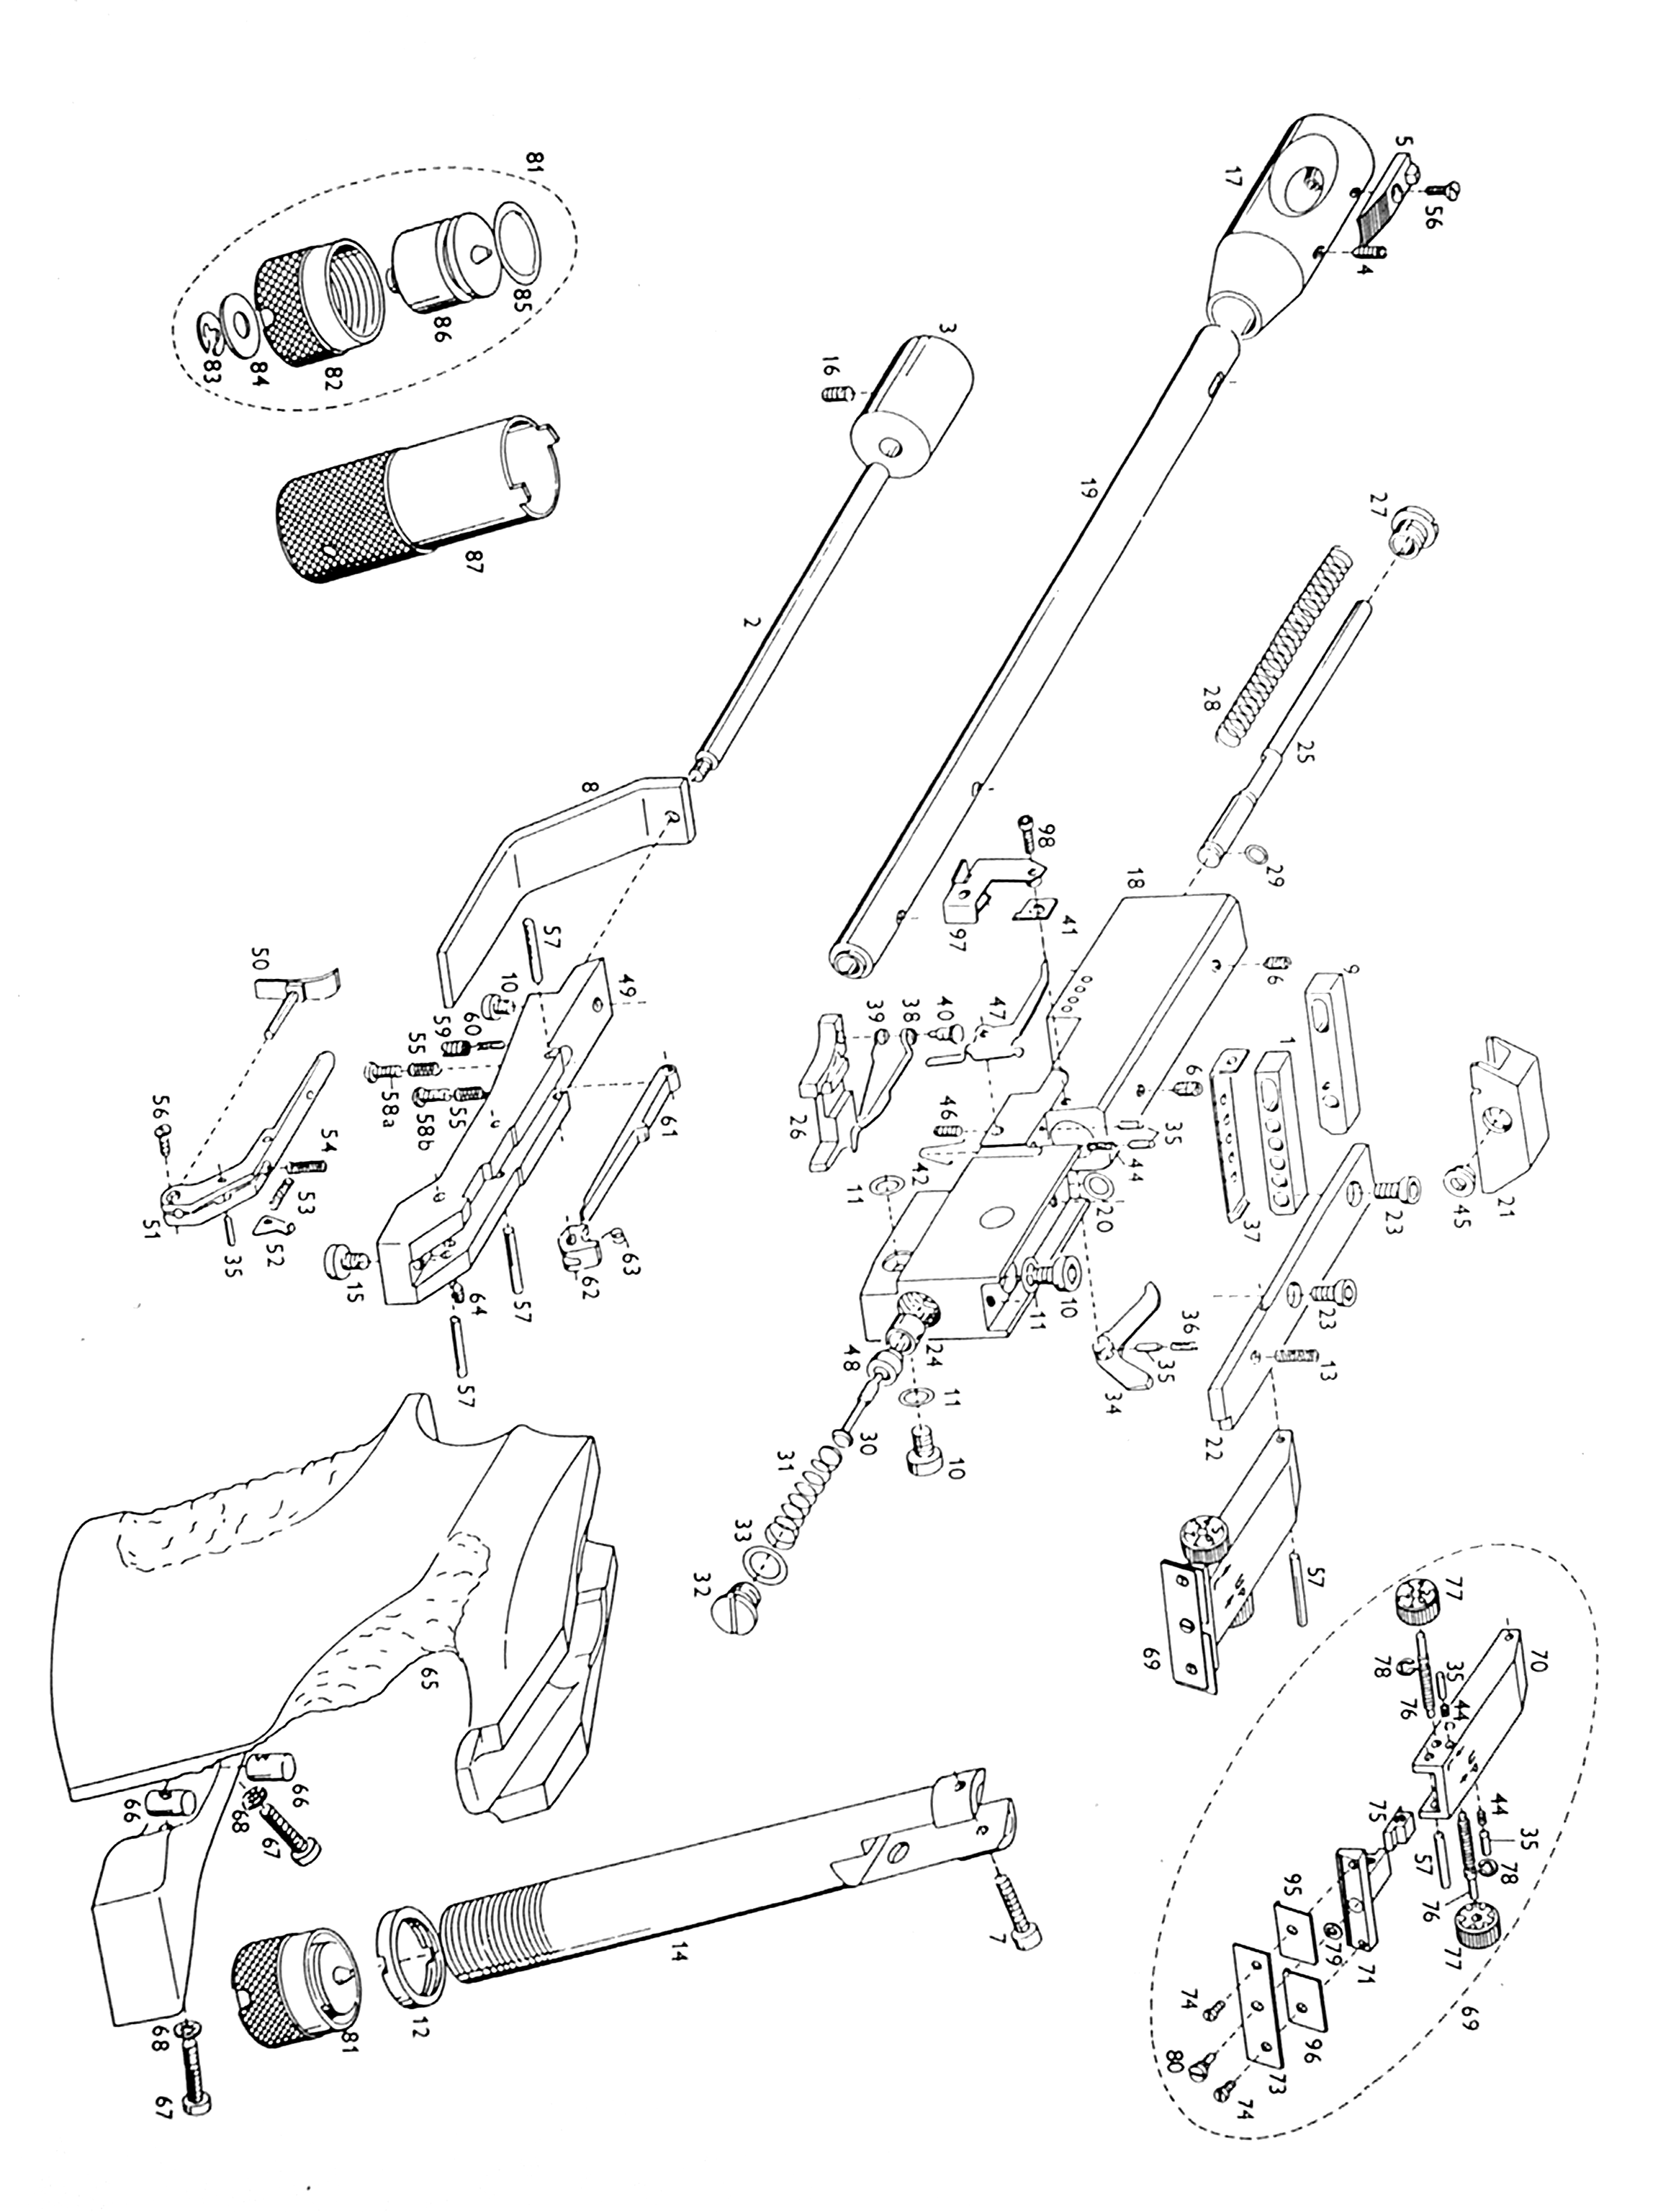

aPPENDIX b - AERON B96 part list

